1. Create a new process by invoking the appropriate system call. Get the process identifier of the currently running process and its respective parent using system calls and display the same using a C program.
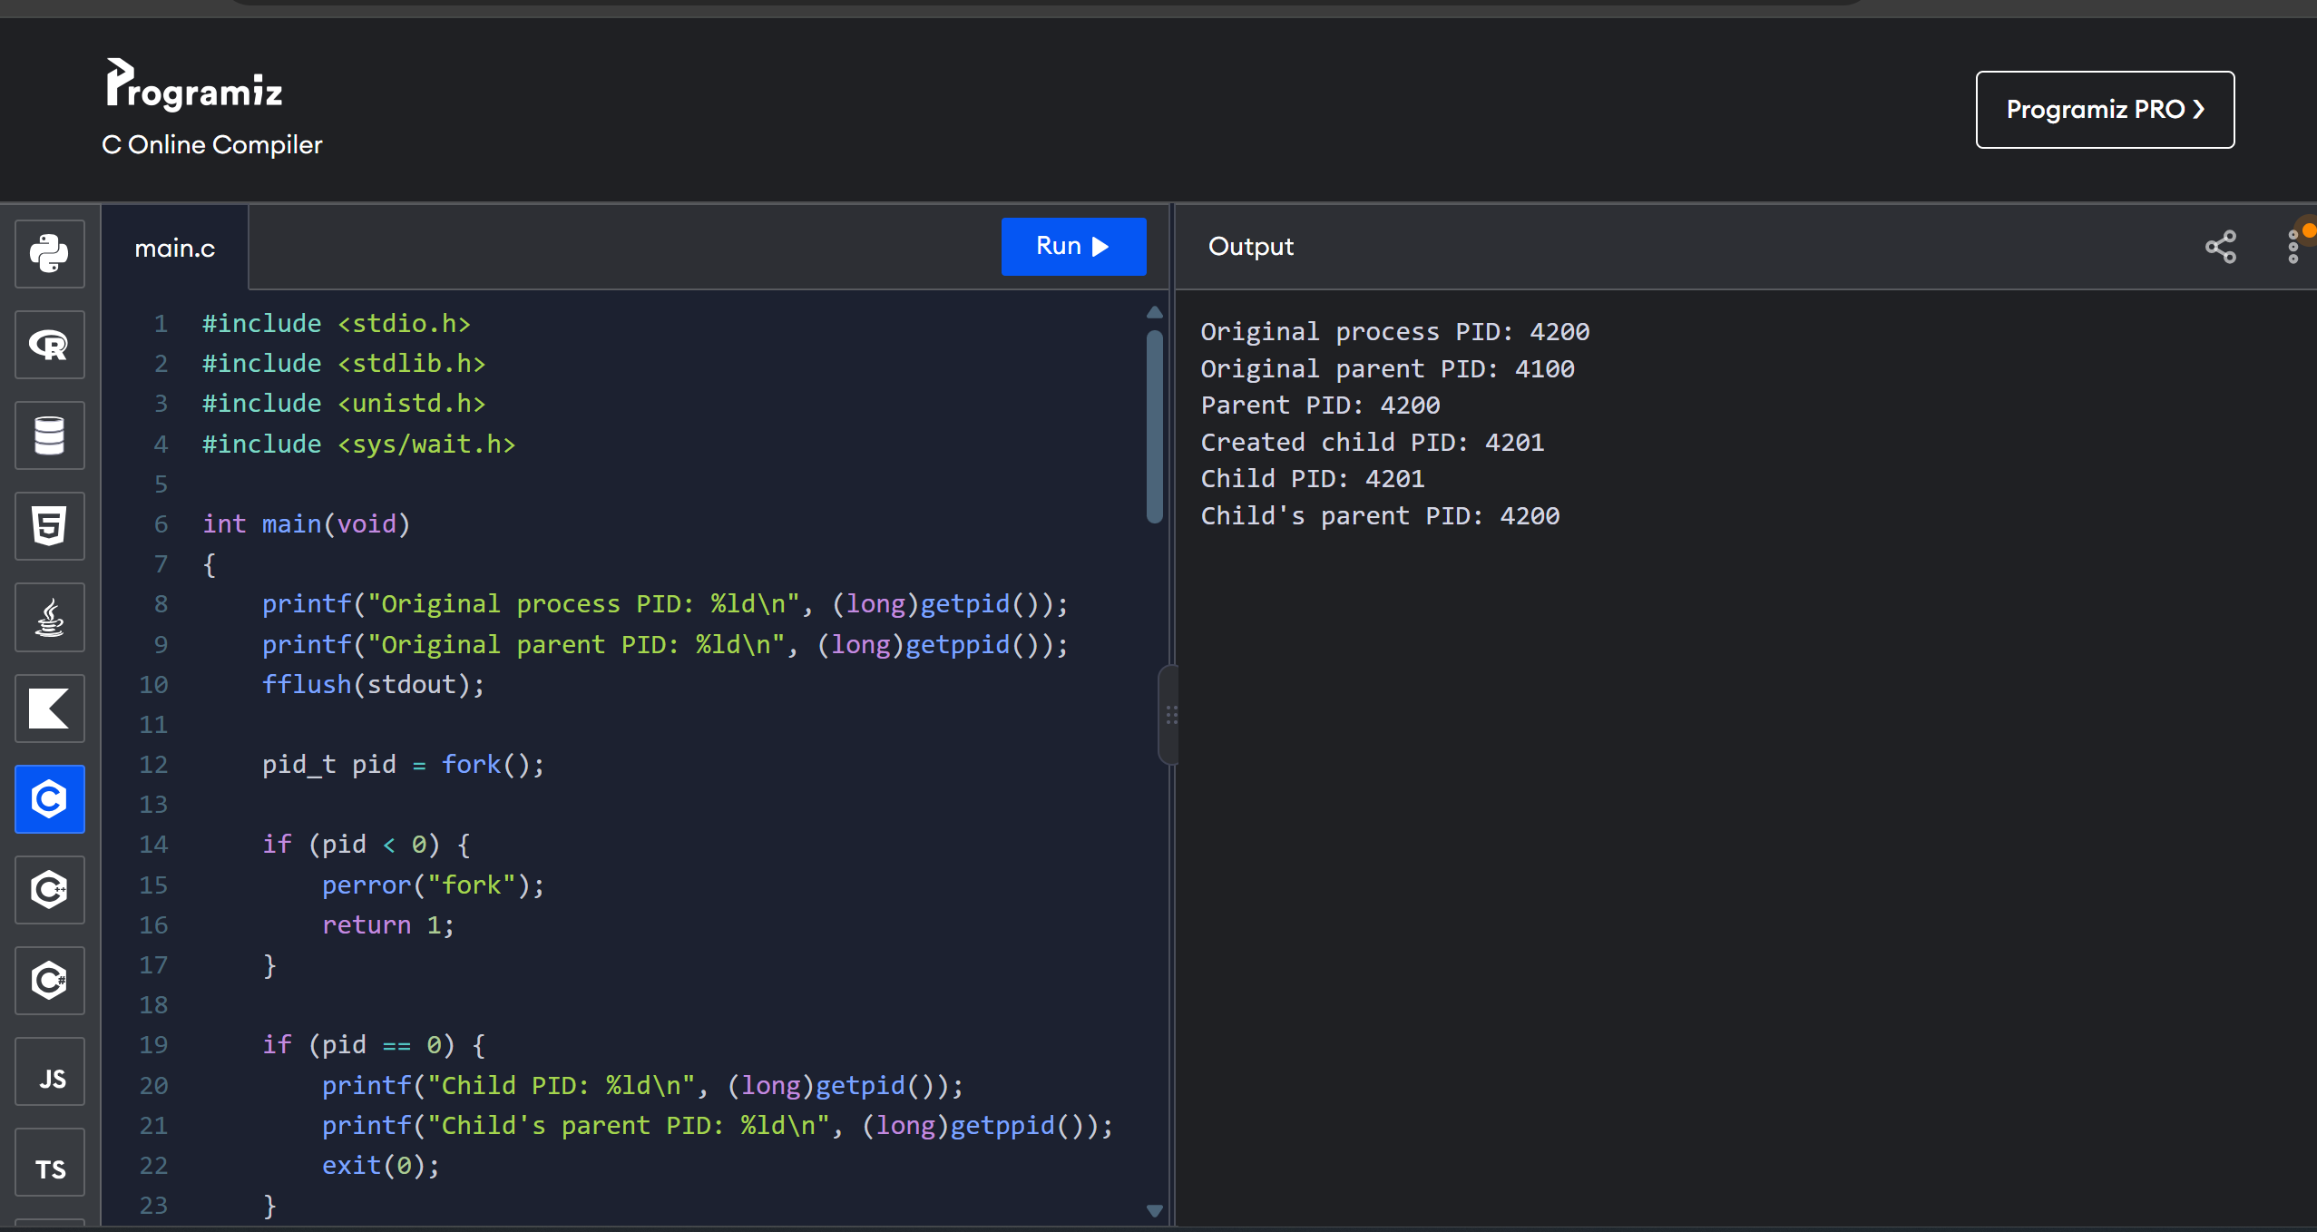

2. Identify the system calls to copy the content of one file to another and illustrate the same using a C program.
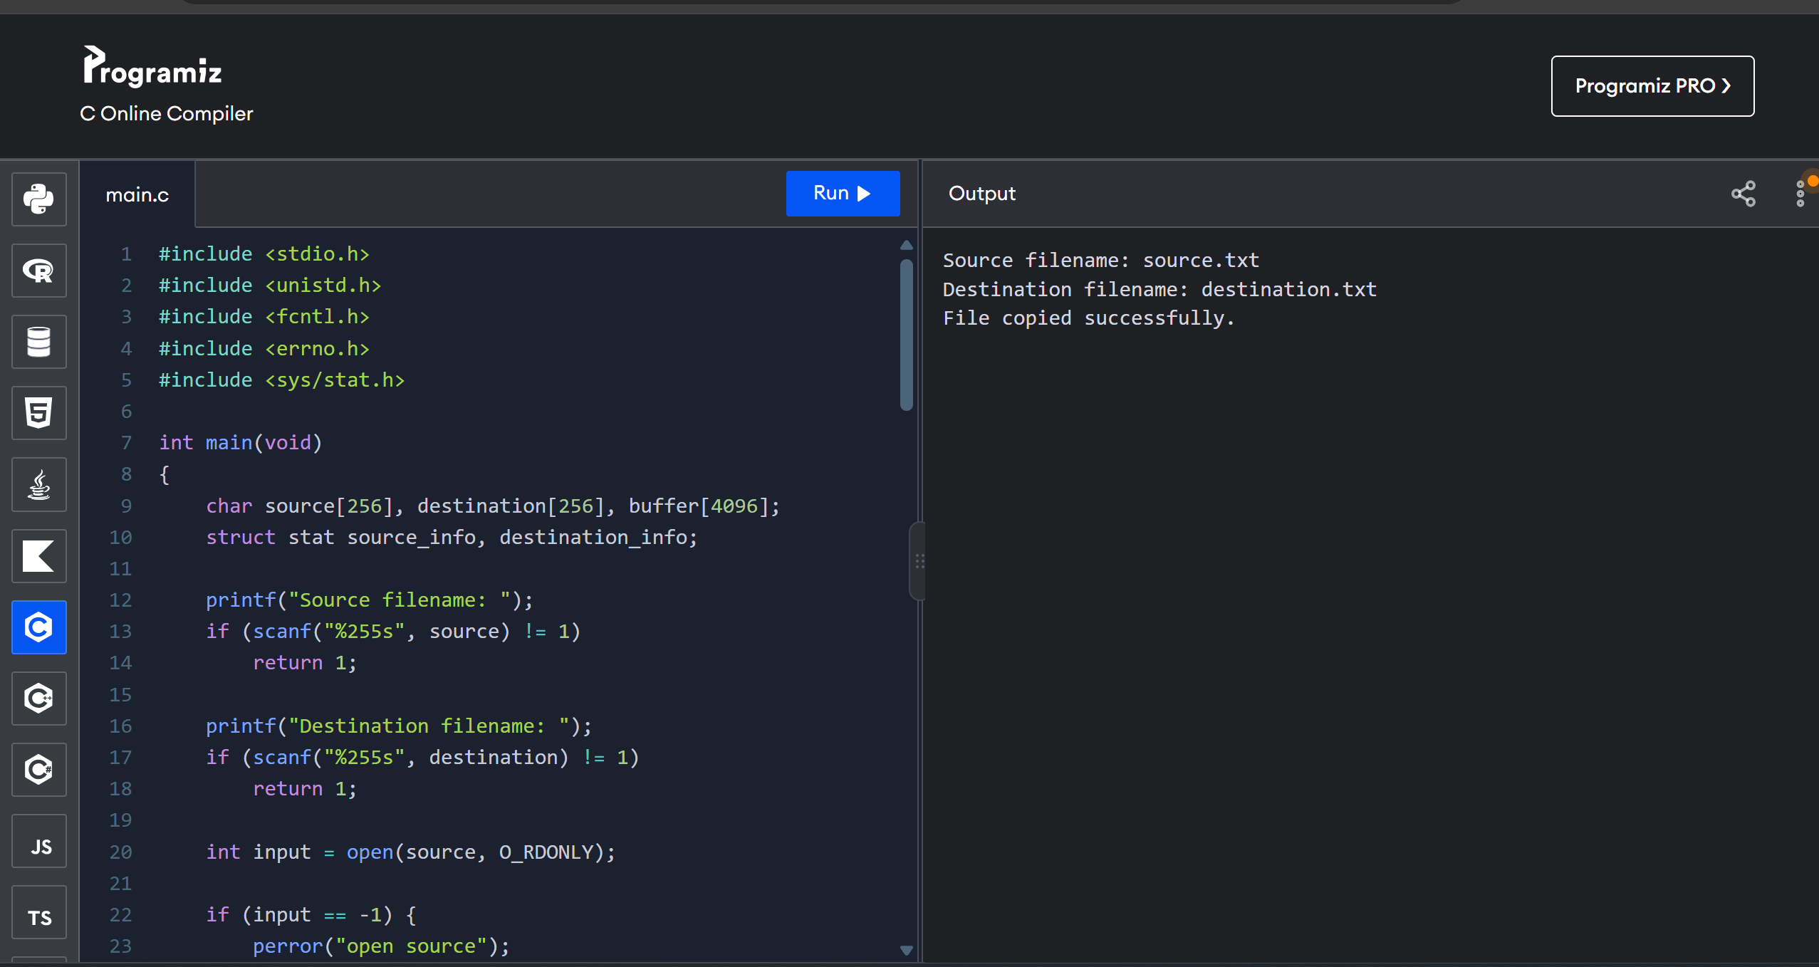

3. Design a CPU scheduling program with C using First Come First Served technique with the following considerations. (a) All processes are activated at time 0. (b) Assume that no process waits on I/O devices.
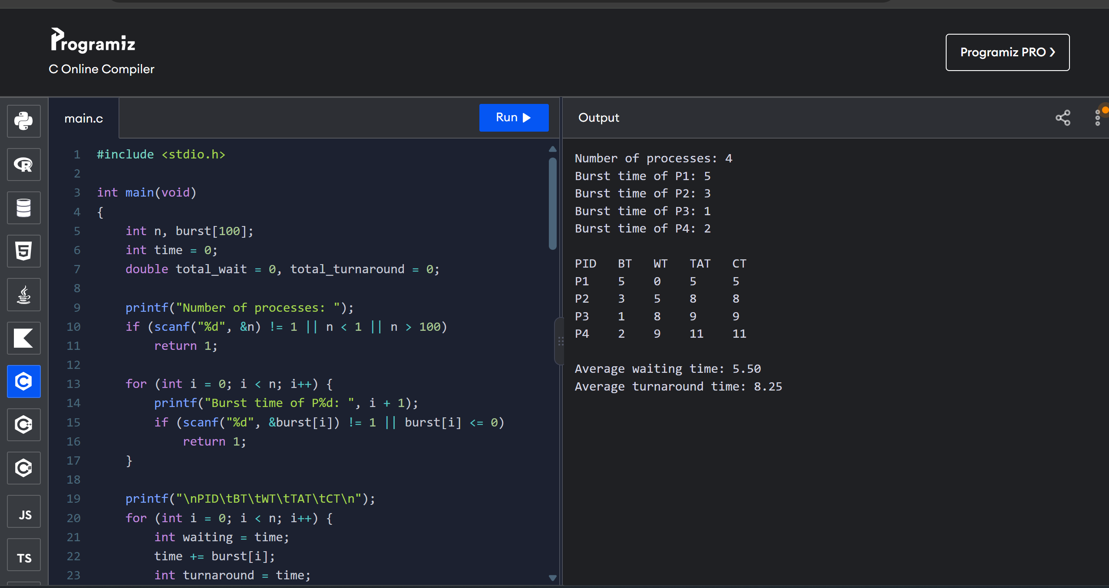

4. Construct a scheduling program with C that selects the waiting process with the smallest execution time to execute next.
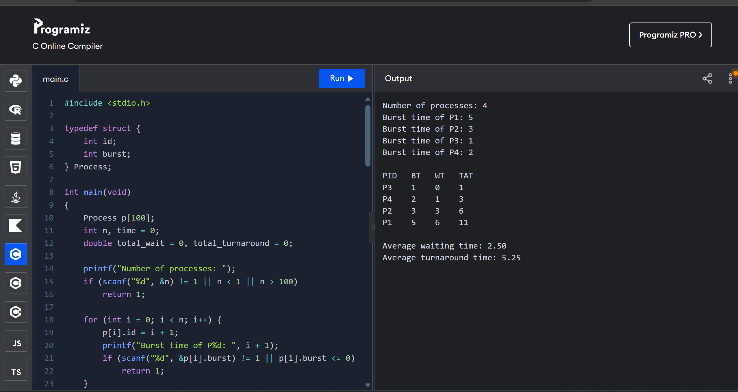

5. Construct a scheduling program with C that selects the waiting process with the highest priority to execute next.
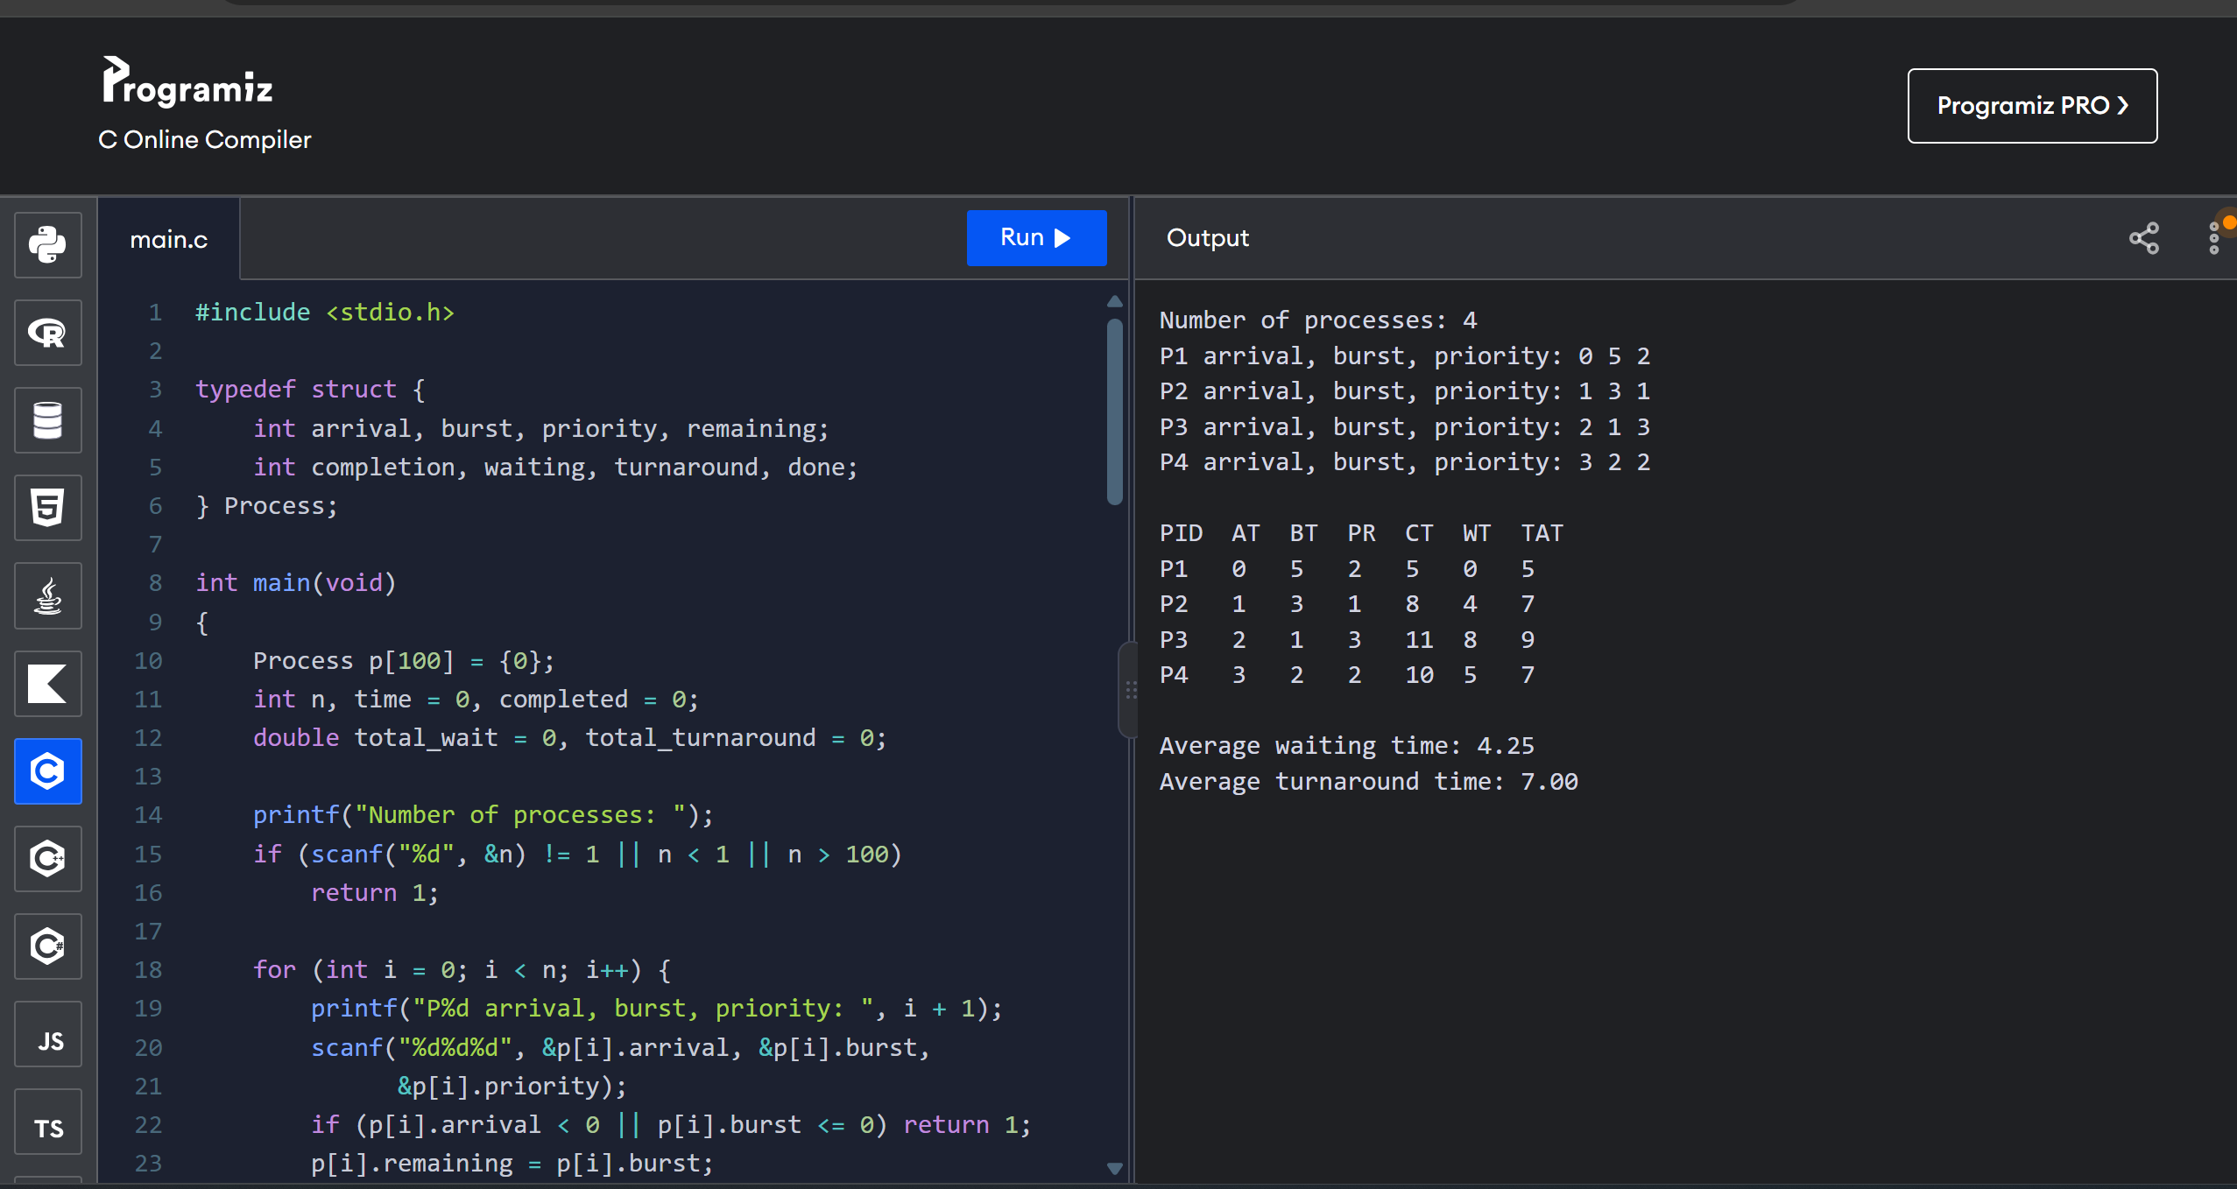

6. Construct a C program to implement preemptive priority scheduling algorithm.
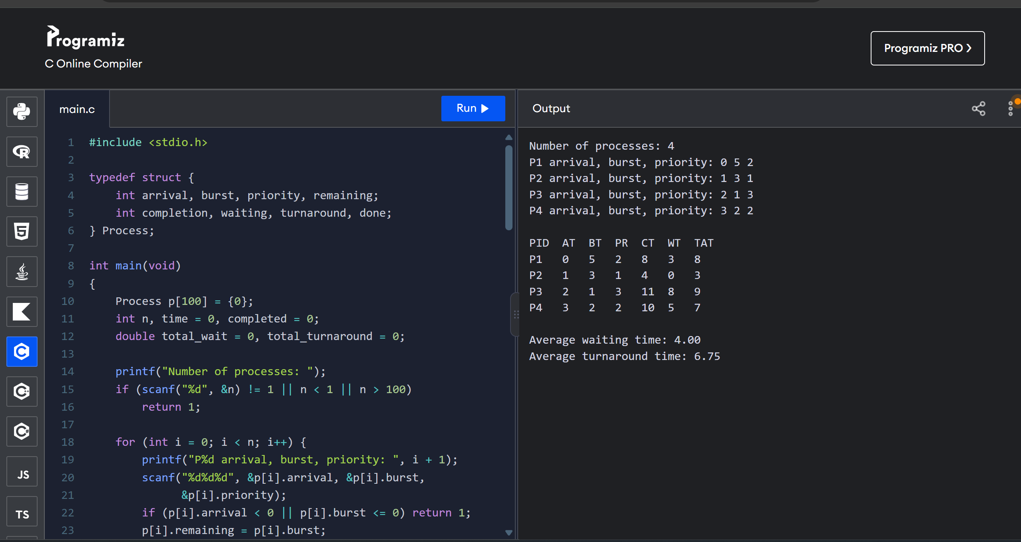

7. Construct a C program to implement a non-preemptive SJF algorithm.
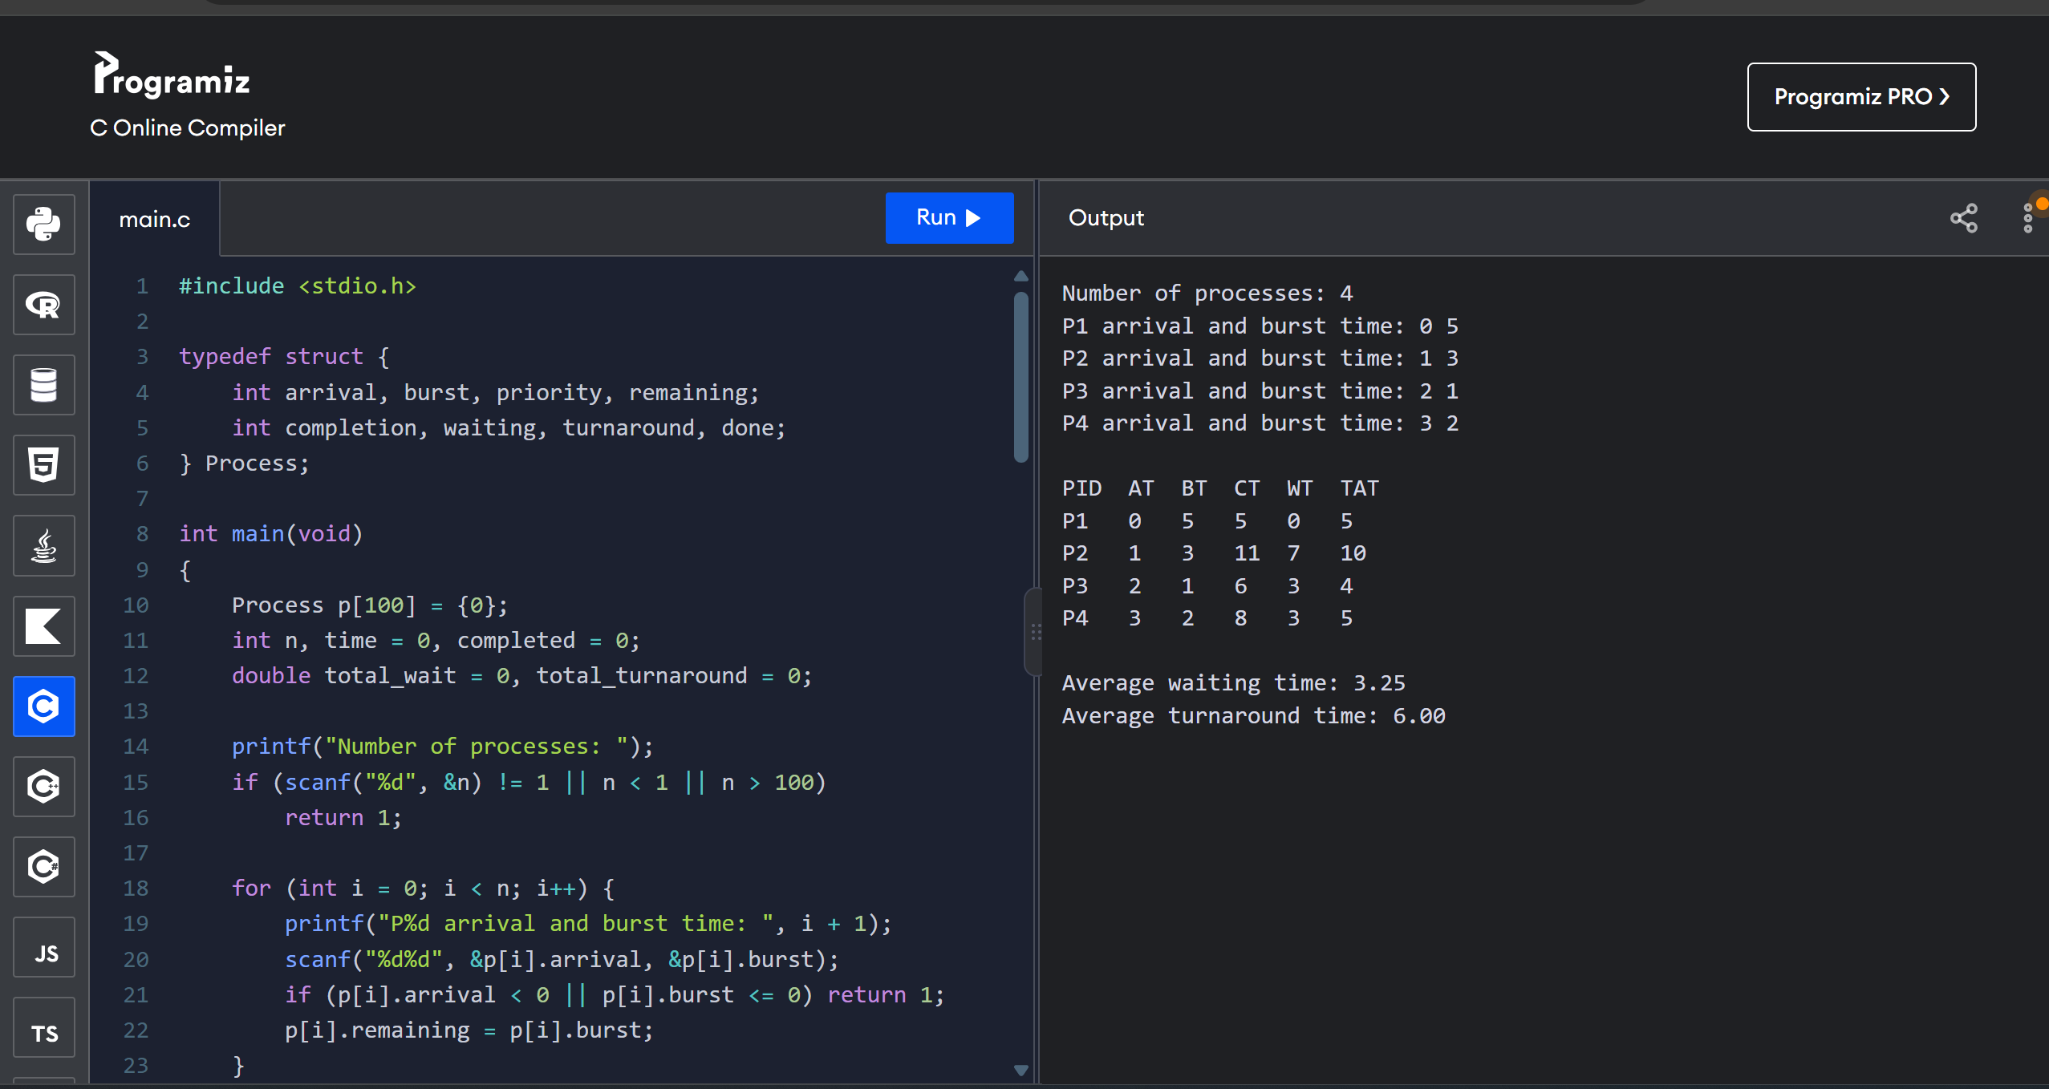

8. Construct a C program to simulate Round Robin scheduling algorithm with C.
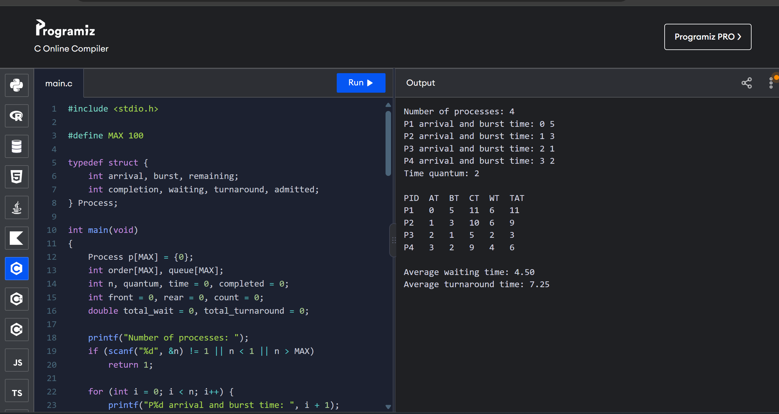

9. Illustrate the concept of inter-process communication using shared memory with a C program.
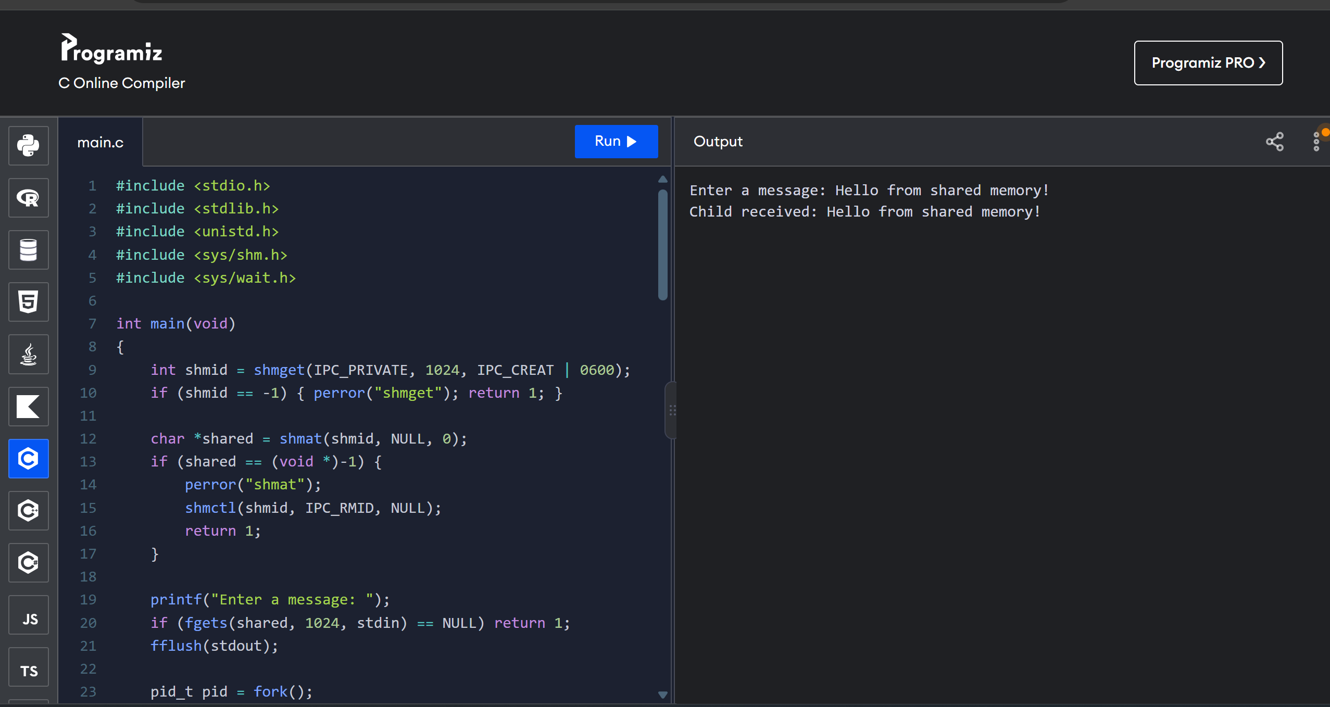

10. Illustrate the concept of inter-process communication using message queue with a C program.
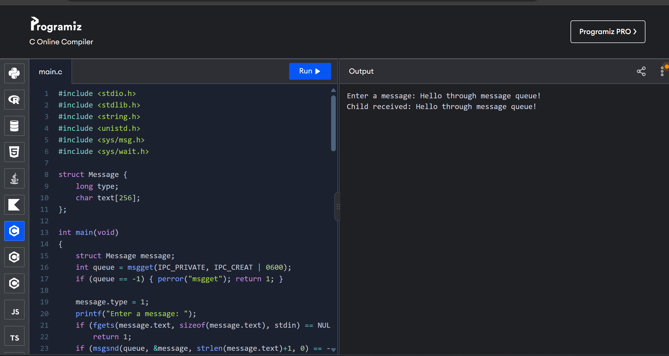

11. Illustrate the concept of multithreading using a C program.
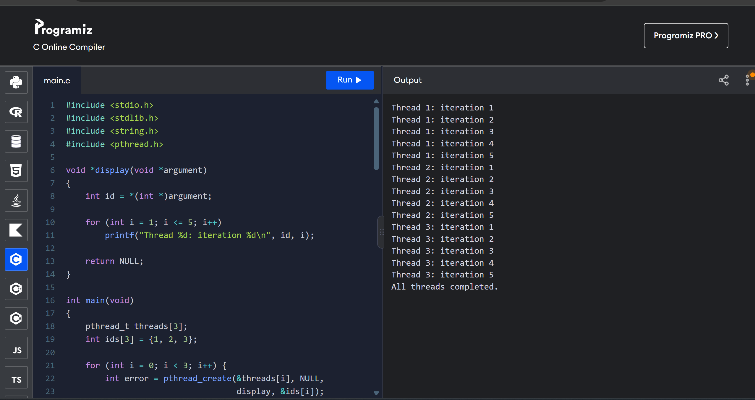

12. Design a C program to simulate the concept of Dining-Philosophers problem.
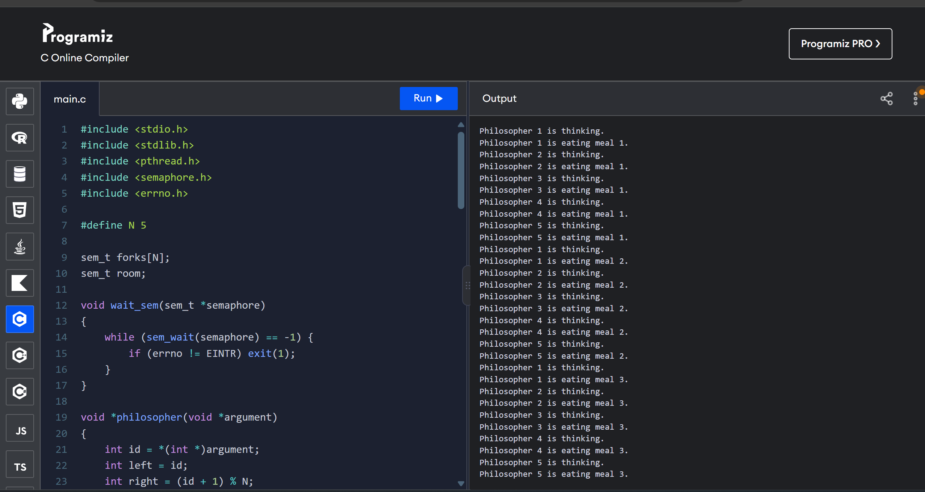

13. Construct a C program for implementation of the various memory allocation strategies.
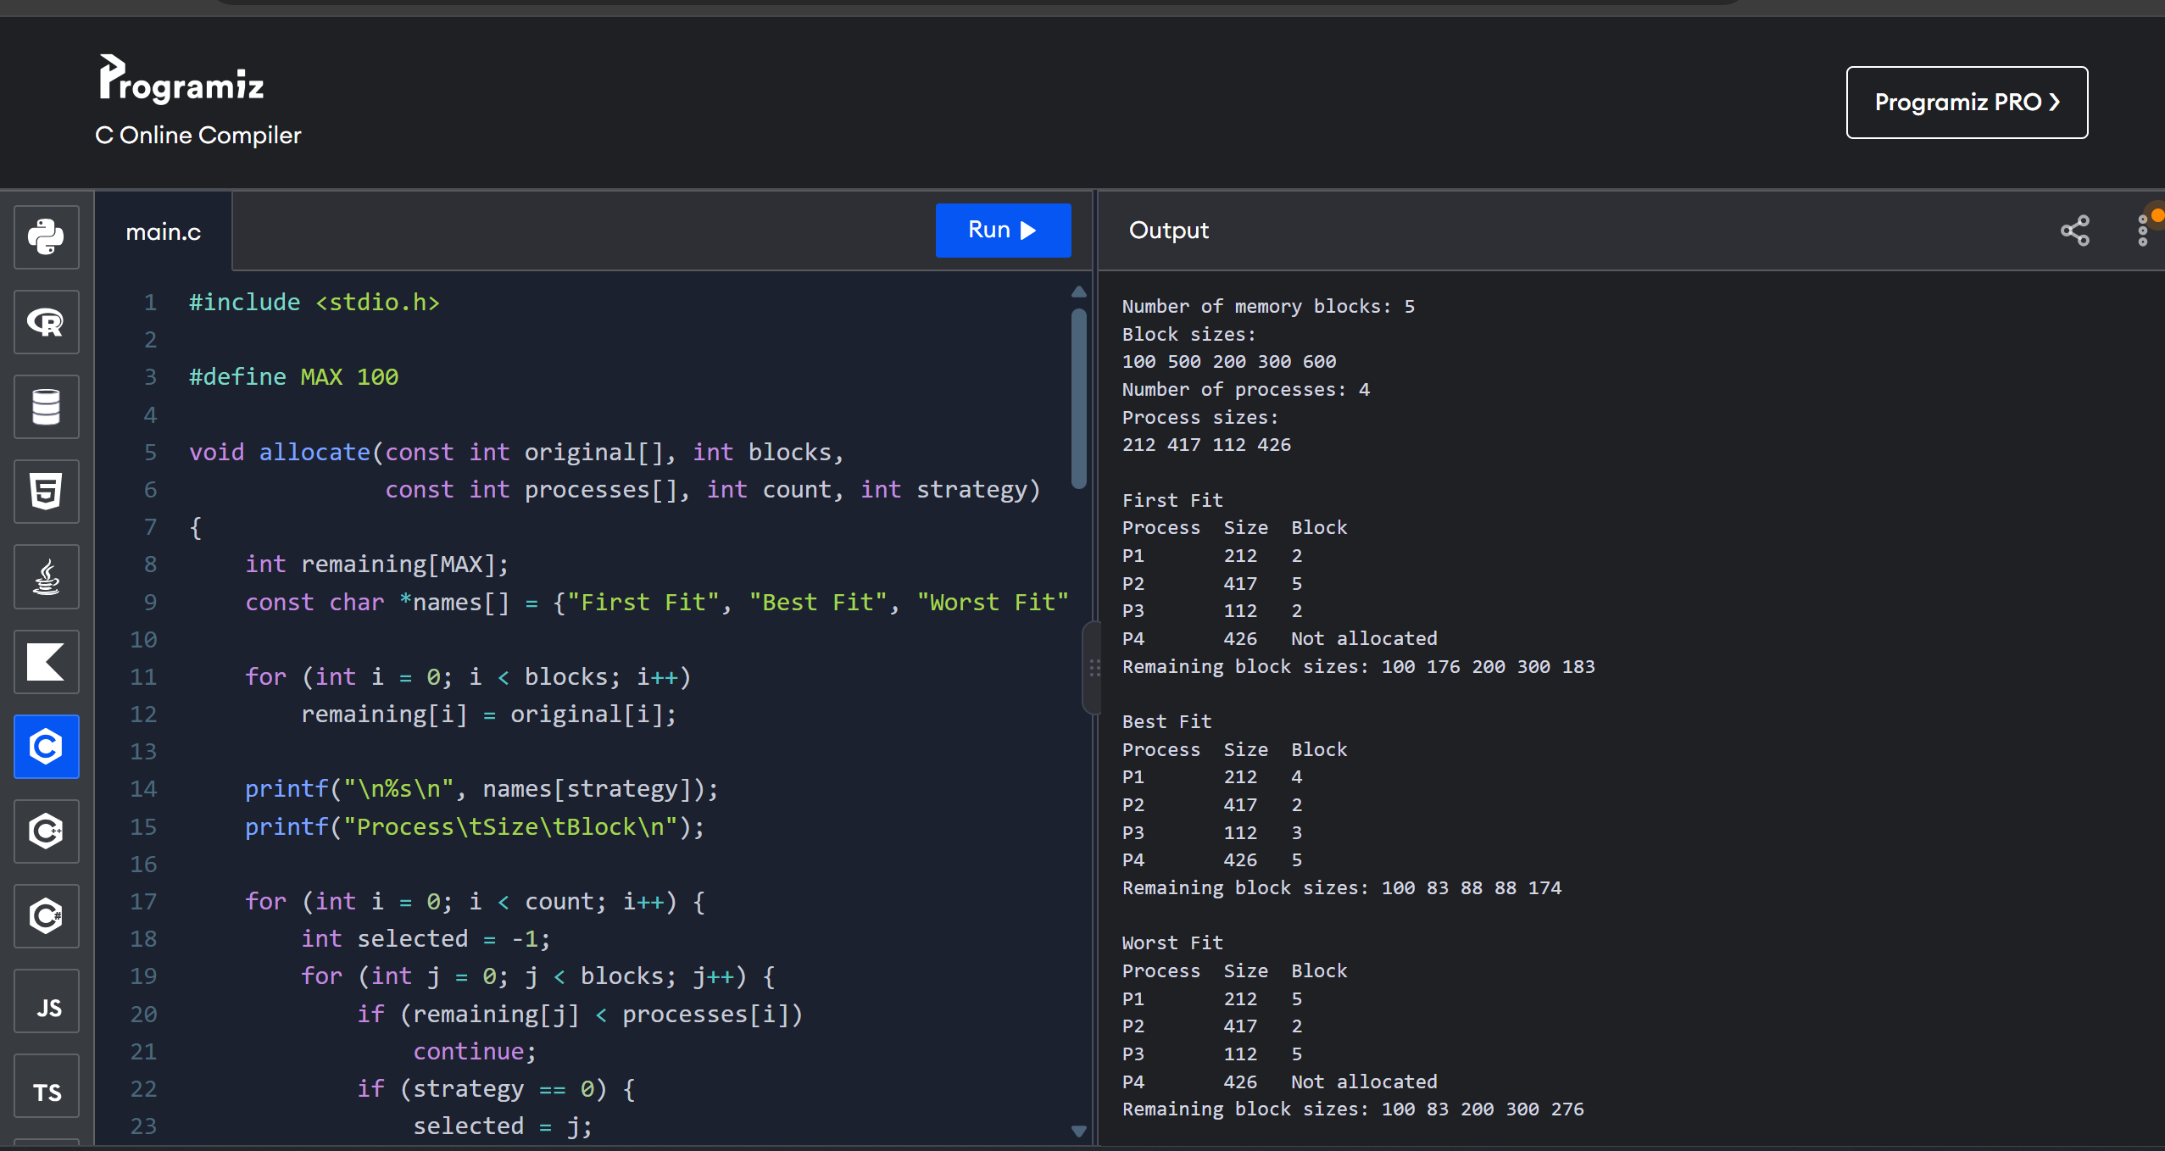

14. Construct a C program to organise the file using a single level directory.
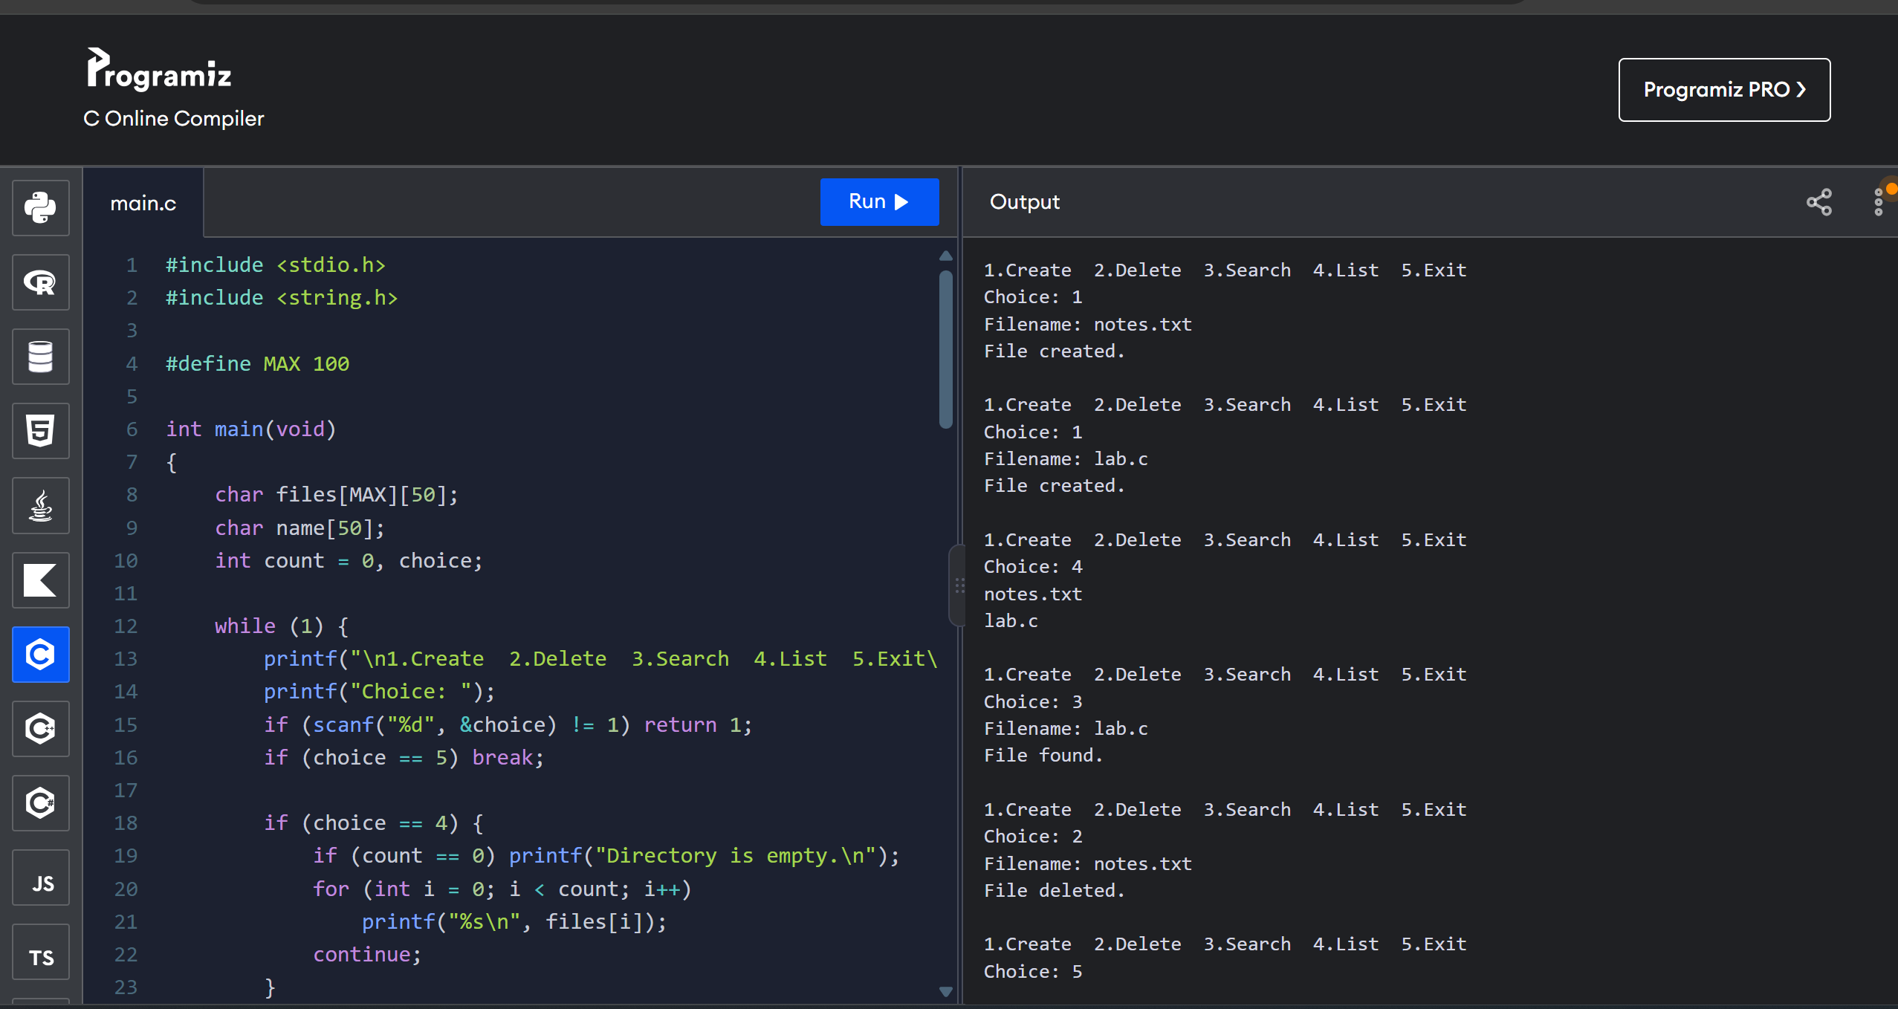

15. Design a C program to organise the file using a two level directory structure.
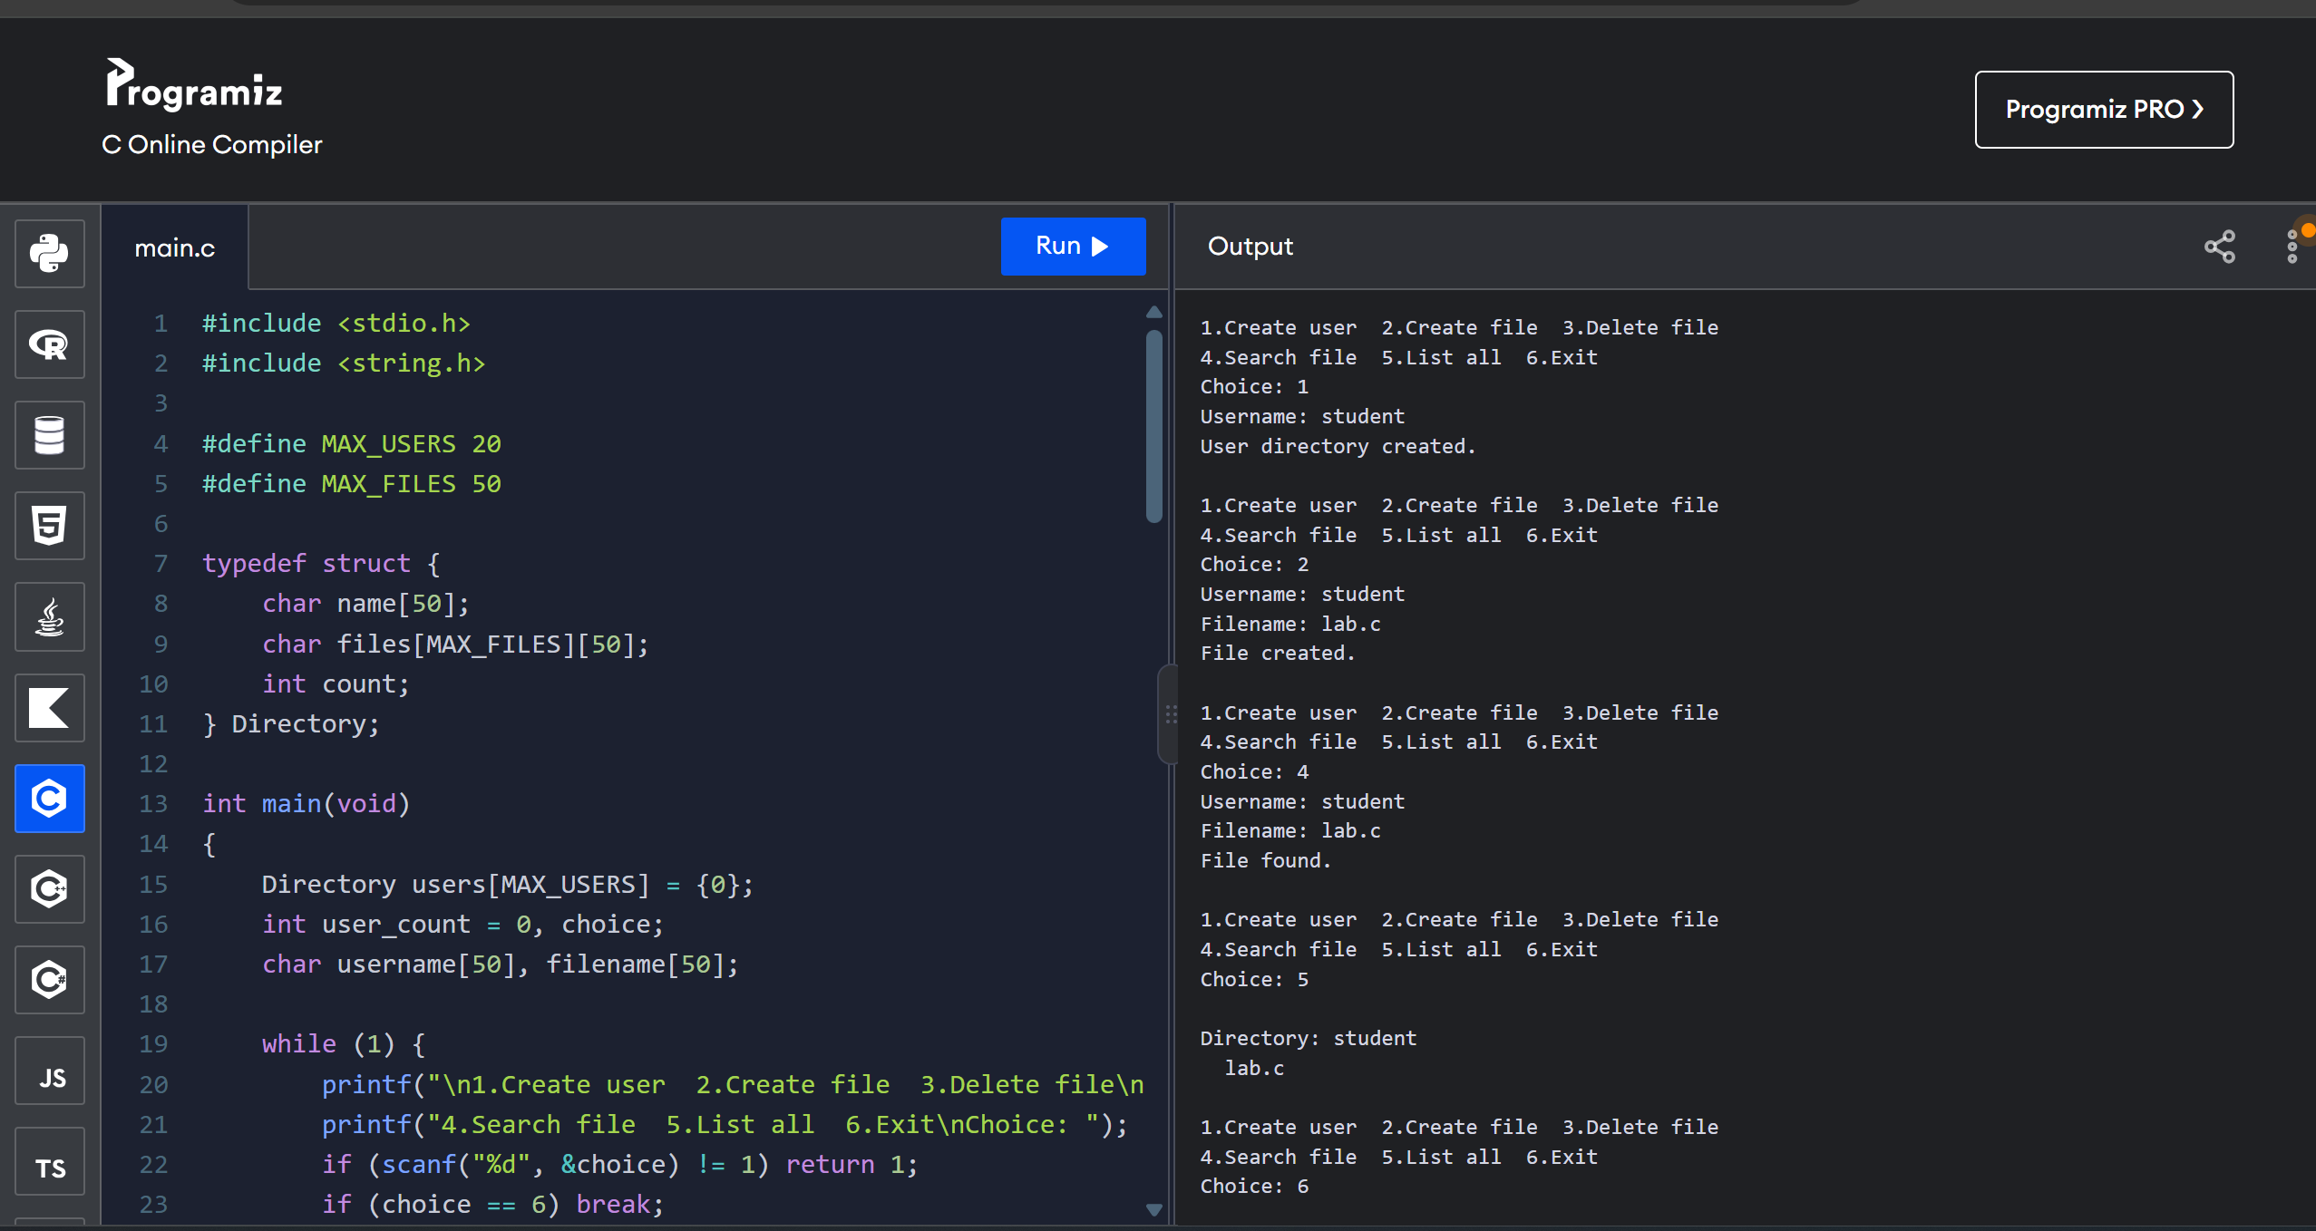

16. Develop a C program for implementing random access file for processing the employee details.
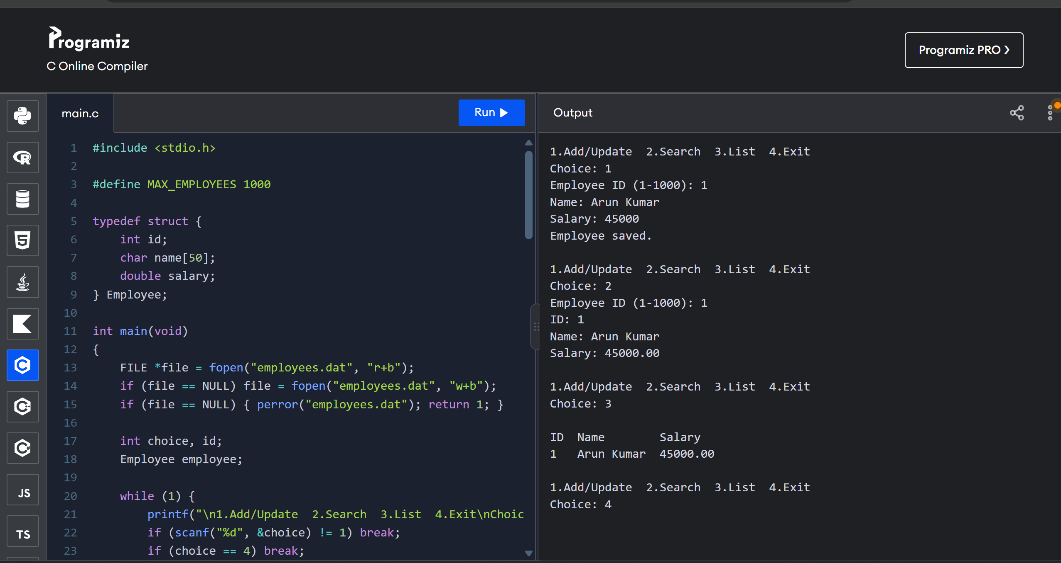

17. Illustrate the deadlock avoidance concept by simulating Banker’s algorithm with C.
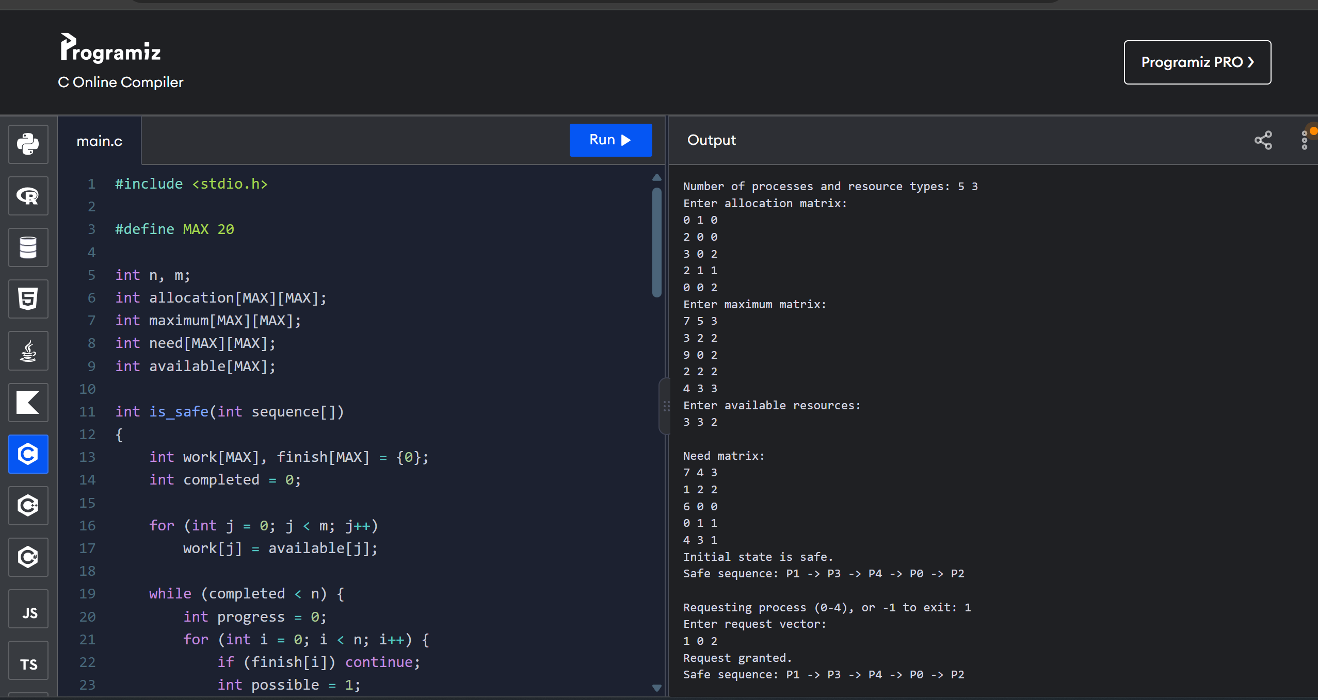

18. Construct a C program to simulate producer-consumer problem using semaphores.
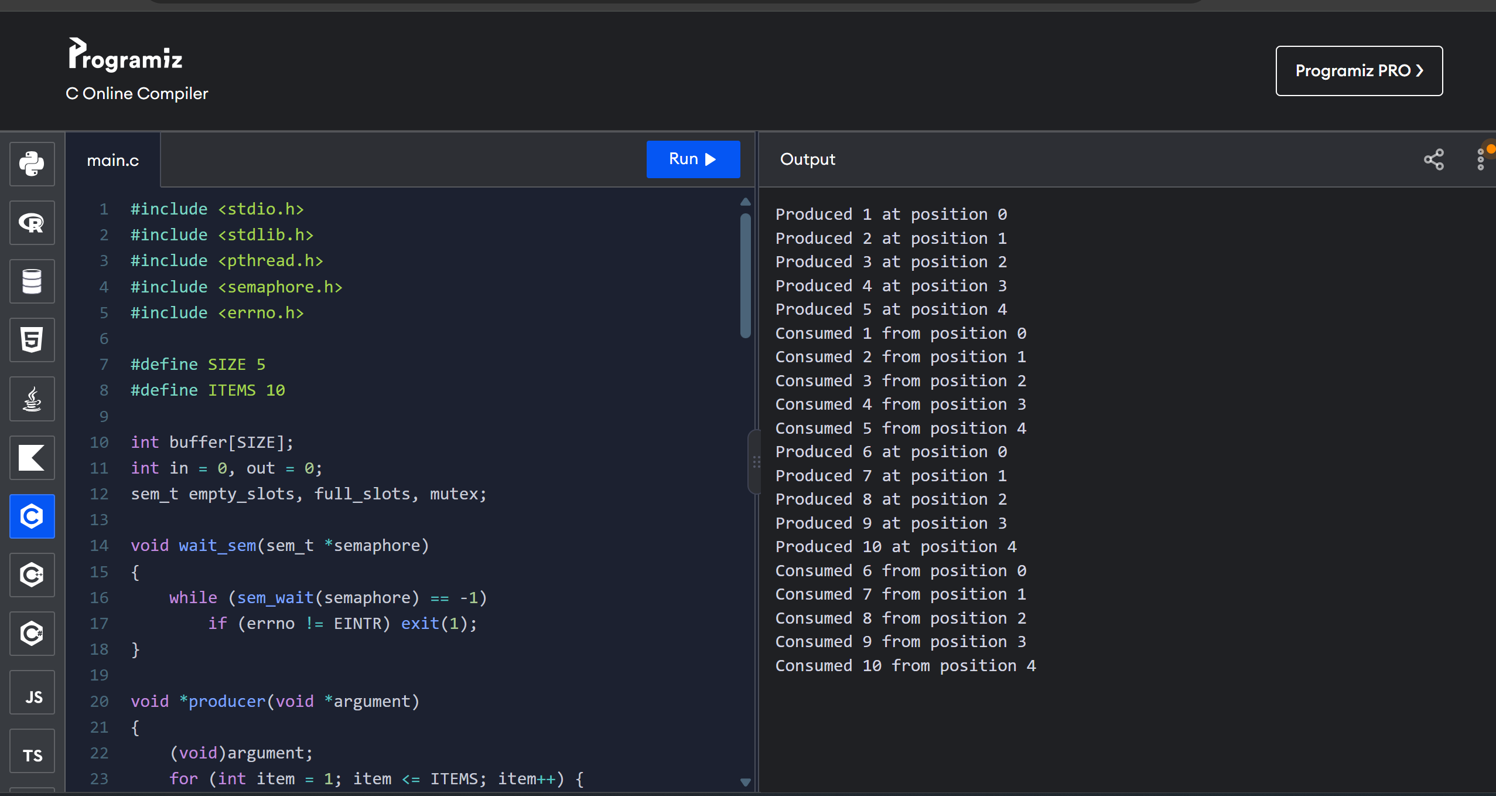

19. Design a C program to implement process synchronization using mutex locks.
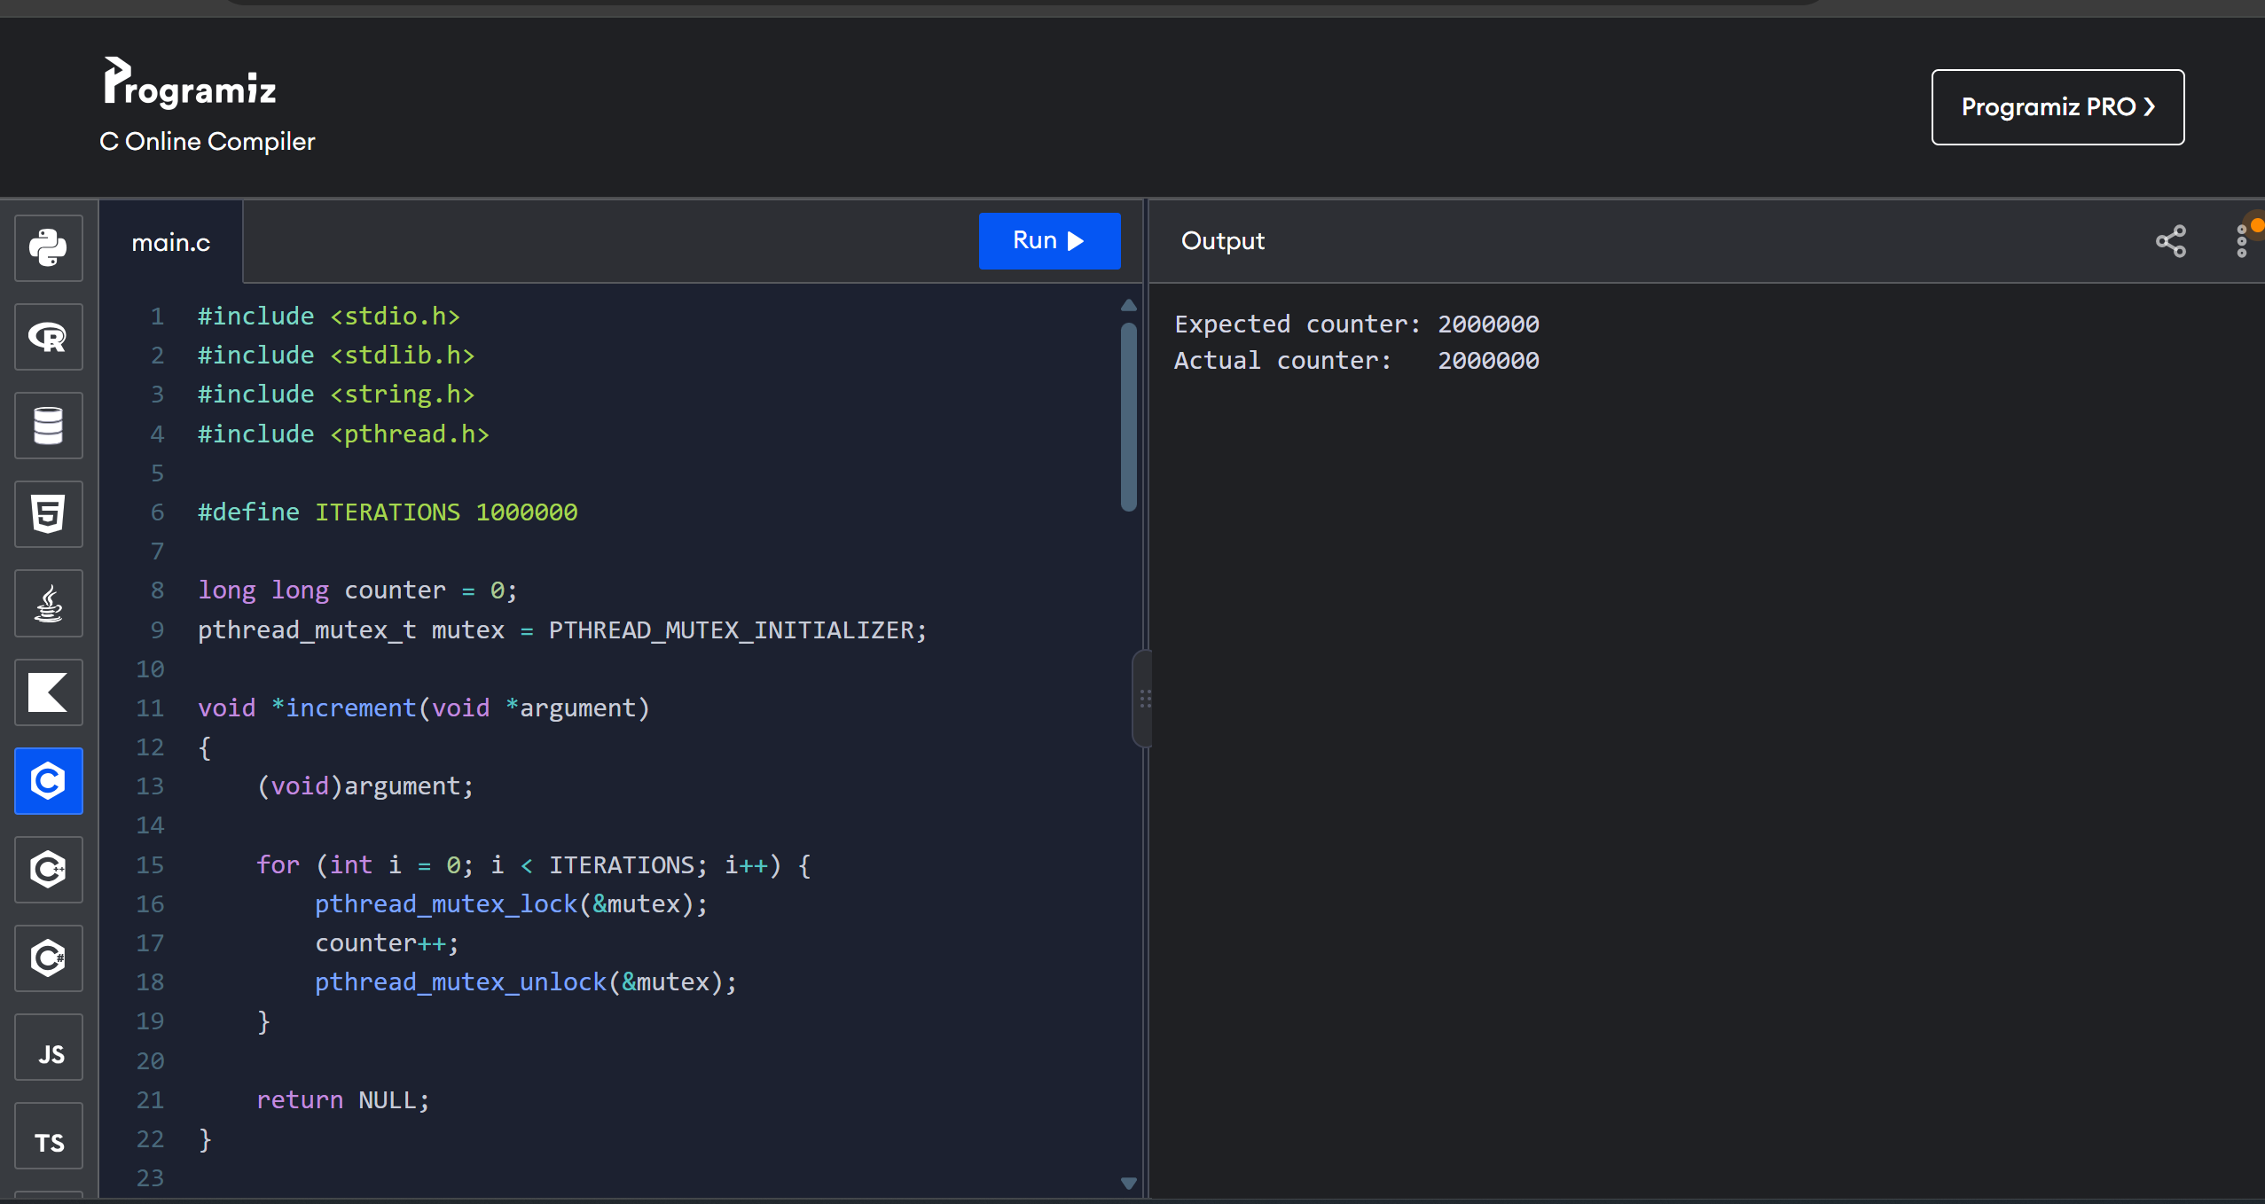

20. Construct a C program to simulate Reader-Writer problem using Semaphores.
